



**SCHOOL OF COMPUTER SCIENCE AND ENGINEERING**

**COURSE: CSE 316 OPERATING SYSTEM**

*SUBMITTED TO:* **Dr. Hardeep Kaur**

**TOPIC**

“Graphical Simulator For Resource Allocation Graphs”

| A. Full name | Anuvindh Krishna P B |
| --- | --- |
| Registration number | 12315058 |
| Roll No | 45 |
| B. Full name | Chris Harris Edmond |
| UID/Registration number | 12321270 |
| Roll No | 48 |
| C. Full name | Paulsonsanio |
| UID/Registration number | 12313062 |
| Roll No | 33 |

**Table of Contents**

1. **Project Overview**
   * Introduction
   * Objective of the Project
   * Scope of the Project
2. **Module-Wise Breakdown**
   * User Interface (UI) Module
   * Page Replacement Algorithms Module
   * Performance Metrics Module
   * Visualization Module
3. **Technology Used**
   * Programming Languages
   * Libraries and Tools
   * Other Tools
4. **Revision Tracking on GitHub**
   * Repository Name
   * GitHub Link
5. **Conclusion and Future Scope**
   * Conclusion
   * Future Scope
6. **Appendix**
   * A. AI-Generated Project Elaboration/Breakdown Report
   * B. Problem Statement
   * C. Solution/Code

**1. Project Overview**

**Introduction**

Resource management is a very important function of contemporary computer systems, as it allows different processes to use limited resources without interference. Detection and prevention of deadlocks is one of the most important issues in process management, where two or more processes are waiting infinitely for resources controlled by other processes.

The Resource Allocation Graph Graphical Simulator offers a dynamic, interactive visual representation of process requests and resource allocations. This simulator enables adding and deleting processes, resources, and allocation/request edges dynamically with a clear graph-based view of the system's state. The simulator also enables users to identify and analyze deadlocks in real time through the use of cycle detection algorithms.

This simulator is especially helpful for students, researchers, and system administrators, allowing them to test various scenarios, learn concepts related to resource allocation, and streamline system performance efficiently.

**Objective of the Project**

The main goals of this project are

* To create an easy-to-use graphical simulator that models resource allocation in the form of directed graphs.
* To provide users with the ability to add and delete processes, resources, and allocation/request edges dynamically.
* To visually identify and mark deadlocks in real time by employing cycle detection algorithms.
* To help students, researchers, and system administrators learn about resource allocation.
* To develop an interactive tool that facilitates learning in the area of operating system process management.

**Scope of the Project**

The Graphical Simulator for Resource Allocation Graphs is of general use across many fields, such as:

* Academic Learning: Facilitates learning deadlock detection and resource allocation for students and teachers.
* Operating System Analysis: Offers a facility for researchers and engineers to examine resource allocation methods.
* Process Management: May be applied in real-world system administration to simulate and detect possible resource allocation problems.
* Dynamic Simulation: Permits real-time updates to the graph of resource allocation, rendering it a good instrument for analyzing varied scenarios.

The project allows for an unlimited number of processes and resources and dynamic removal and addition of processes, resources, and edges to provide total flexibility in simulation.

**2. Module-Wise Breakdown**

The simulator consists of the following key modules:

**2.1 User Interface (UI) Module**

* The User Interface (UI) Module facilitates an interactive, user-friendly atmosphere for handling processes and resources. It enables users to:
* Insert and delete resources and processes dynamically.
* Create and delete request edges (process → resource) and allocation edges (resource → process).
* Initiate deadlock detection from an easy-to-use control panel.
* Observe real-time updates of the graph with a organized visualization.

The UI is developed with Tkinter for graphical components and Matplotlib for effortless rendering of graphs. 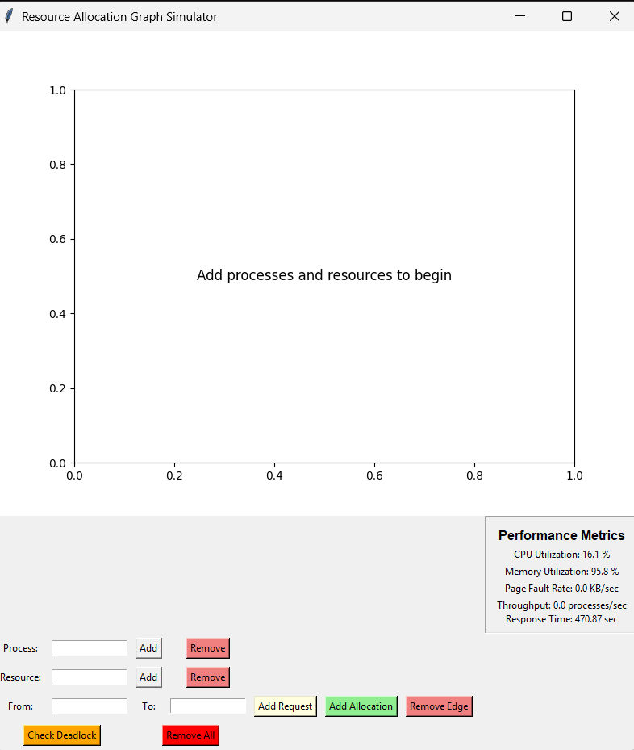

* 1. **Page Replacement Algorithms Module**

Page replacement algorithms are essential memory management techniques that are employed when a computer's physical memory is full and needs to load a new page. The operating system is then tasked with finding a page that is already stored and must be deleted to create room for the new page.

### **Fundamental Algorithms**

#### **1. First-In-First-Out (FIFO)**

* The oldest page in memory is the first to be replaced when a new page needs to be fetched.
* Easily performed with minimal computational requirements.
* Can suffer from Belady's anomaly, in which adding more memory frames paradoxically increases page fault rates.

#### **2. Least Recently Used (LRU)**

* Replaces the page that has been least accessed or unreferenced for the longest period of time.
* Is better than FIFO in predicting page usage patterns for the future.
* Tracks overall page access history to enable well-informed replacement decisions.

#### **3. Optimal Page Replacement**

* Replaces the page most likely to be idle for the greatest amount of time in the future.
* Represents the perfect algorithm theoretically with a minimum number of page faults.
* It is impossible to perform perfectly in practice due to the inability to precisely predict future page access.

### **4. Selection Criteria**

* Minimize the occurrence of page faults while the program is running.
* Reduce overall system memory access time and system delay.
* Improve system performance and memory usage effectiveness.

### **5. Implementation Considerations**

* Limited physical memory constraints.
* The pattern and frequency of webpage use.
* The computer resources needed for page tracking and page management.

**2.3 Performance Metrics Module**

Performance metrics are significant indicators that offer insight into system operation efficiency and resource consumption, allowing for an understanding of system behavior and performance optimization.

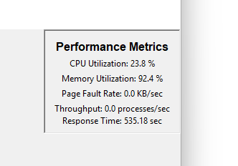

**Key Performance Metrics**

### **1. CPU Utilization**

* Quantifies the percentage of processing time spent by the CPU performing tasks
* Current implementation: 17.4% (low processor utilization)

### **2. Memory Utilization**

* Measures the percentage of total available memory being consumed
* Current implementation: 94.2% (very high memory utilization)

### **3. Page Fault Rate**

* Monitors page faults per unit time
* Current implementation: 0.0 KB/sec (no page faults)

### **4. Throughput Time**

* Computes processes finished per unit time
* Current implementation: 0.0 processes/sec (no process completion)

### **5. Response Time**

* Records time from task start to first system response
* Current implementation: 8.55 seconds (high response time)

## **Importance of Performance Metrics**

* Early identification of system performance problems
* Resource allocation optimization
* System tuning and predictive maintenance
* Benchmarking of performance

## **Metric Interpretation**

* High memory usage (94.2%) indicates possible memory limitations
* Low CPU usage (17.4%) implies underutilized processing capacity
* Long response time (8.55 sec) could indicate system overhead or resource constraints

**2.4 Visualization Module**

* Uses Matplotlib or Tkinter to graphically display:
  + Memory frames at each step.
  + Page replacements in real-time.
  + Bar graphs comparing performance.

**3. Functionalities**

The Resource Allocation Graph Simulator provides the following features:

**✔ Graph Managemen**t – Allows dynamic process and resource addition, deletion, and modifications within the allocation graph.

**✔ Edge Interaction** – Facilitates creation and maintenance of request and allocation edges between resources and processes.

**✔ Deadlock Detection** – Uses sophisticated cycle detection algorithm to detect possible resource deadlock situations.

**✔** **Visual Representation** – Offers graphical representation of resource allocation relationships and system dependencies in real time.

**✔ Performance Monitoring** – Continuously monitors and shows the system performance metrics such as CPU use, memory, page fault rates, throughput, and response time.

**4. Technology Used**

**Programming Languages**

* **Python** – Used for implementing algorithms, handling logic, and visualization.

**Libraries and Tools**

* **NetworkX** – Used for advanced graph management and complex network analysis.
* **Matplotlib** – Enables sophisticated graphical representation and visualization of system metrics.
* **Tkinter** – Provides interactive graphical user interface (GUI) for system interaction.
* **Psutil** – Facilitates real-time system performance monitoring and resource tracking.

**Other Tools**

* **GitHub –** Version control and collaborative development platform.
* **Jupyter Notebook –** Interactive development and algorithm prototyping environment.
* **Visual Studio Code –** Integrated development environment for code editing and debugging.

**5. Flow Diagram**

**Flowchart Representation**

The flow of execution in the simulator is: 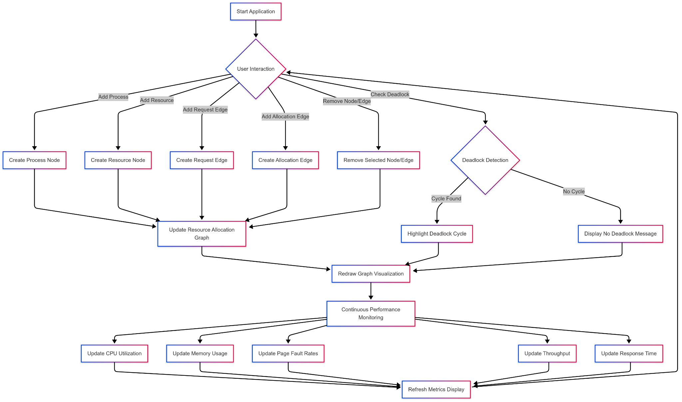

1️. **User Interactions**

* Add processes to the system
* Create resource nodes
* Establish request and allocation edges
* Initiate deadlock detection

2️. **Graph Management**

* Dynamically update resource allocation graph
* Track connections between processes and resources
* Visualize system resource state

3️. **Deadlock Detection**

* Scan resource graph for potential cycles
* Identify resource conflict points
* Highlight potential system blockages

4️. **Performance Monitoring**

* Track CPU utilization
* Monitor memory usage
* Measure page fault rates
* Calculate system throughput
* Analyze response times

**6. Revision Tracking on GitHub**

**Repository Name:**

**Resource-Allocation-Graph-Simulator**

**GitHub Link:**

<https://github.com/chris-h-edmond/Resource-Allocation-Graph-Simulator/>

**7. Conclusion and Future Scope**

**Conclusion**

This Page Replacement Algorithm Simulator successfully demonstrates how different memory management techniques handle page replacements. The FIFO, LRU, and Optimal algorithms were implemented, analysed, and compared based on page faults and hit ratios.

From the results:

* FIFO is simple but suffers from Belady’s anomaly.
* LRU is more efficient as it considers past usage patterns.
* Optimal provides the best results, but it is impractical for real-world systems.

**Future Scope**

Additional Algorithms: Implement Clock (Second Chance) and Random Page Replacement algorithms.  
 GUI Enhancements: Add interactive animations for real-time memory visualization.  
 Machine Learning: Train an AI model to predict and optimize page replacements.  
 Cloud-Based Simulation: Deploy the tool as a web application.

**8. References**

* **Operating System Concepts** – Silberschatz, Galvin, Gagne
* **Modern Operating Systems** – Andrew S. Tanenbaum
* **GeeksforGeeks** – Page Replacement Algorithms
* **TutorialsPoint** – Virtual Memory
* **Research Gate -** Research Papers

**Appendix**

**AI-Generated Project Elaboration/Breakdown Report**

**1. Project Overview Goals**

* Create an interactive graphical simulator for resource allocation and deadlock detection
* Develop a user-friendly tool for modeling process and resource interactions
* Enable dynamic graph management and real-time system analysis
* Support educational and research purposes in operating system process management

**Expected Outcomes**

* A comprehensive simulator that visualizes resource allocation graphs
* Interactive interface for adding/removing processes and resources
* Real-time deadlock detection mechanism
* Performance monitoring of system resources
* Educational tool for understanding process management concepts

**Scope:**

* Academic learning environments
* Operating system research and analysis
* Process management simulation
* Dynamic resource allocation modeling
* Supporting unlimited processes and resources

**2. Module-Wise Breakdown**

**2.1 User Interface (UI) Module *Purpose:***

* Provide interactive environment for managing processes and resources
* Enable dynamic graph manipulation
* Facilitate user interactions

**Key Functionalities:**

* Dynamic insertion and deletion of resources and processes
* Create and manage request and allocation edges
* Initiate deadlock detection
* Render real-time graph updates

**2.2 Page Replacement Algorithms Module**

Purpose:

* Implement memory management techniques
* Simulate page replacement strategies
* Optimize memory utilization

Algorithms Implemented:

1. First-In-First-Out (FIFO)
2. Least Recently Used (LRU)
3. Optimal Page Replacement

Selection Criteria:

* Minimize page faults
* Reduce system memory access time
* Improve system performance

**2.3 Performance Metrics Module Purpose:**

* Monitor and analyze system performance
* Track resource utilization
* Provide insights into system behavior

Key Performance Metrics:

* CPU Utilization
* Memory Utilization
* Page Fault Rate
* Throughput Time
* Response Time

**2.4 Visualization Module Purpose:**

* Graphically represent system states
* Visualize memory frames and page replacements
* Compare algorithm performances

**3. Functionalities**

* Dynamic graph management
* Edge interaction capabilities
* Advanced deadlock detection
* Real-time visual representation
* Continuous performance monitoring

**4. Technology Recommendations**

Programming Language

* Python

Libraries and Tools

* NetworkX: Graph management
* Matplotlib: Visualization
* Tkinter: GUI development
* Psutil: Performance monitoring

Version Control

* GitHub for collaborative development
* Jupyter Notebook for prototyping

**5. Execution Plan**

Step 1: Development Environment Setup

* Install required Python libraries
* Configure development tools
* Initialize GitHub repository

Step 2: UI Module Implementation

* Develop interactive graphical interface
* Create controls for graph manipulation

Step 3: Algorithm Module Development

* Implement page replacement algorithms
* Create performance tracking mechanisms

Step 4: Visualization Module Creation

* Develop real-time graphing capabilities
* Design performance metric visualizations

Step 5: Testing and Validation

* Test with various input scenarios
* Validate algorithm performances
* Verify deadlock detection accuracy

Step 6: Optimization and Refinement

* Improve algorithm efficiency
* Enhance visualization clarity
* Optimize performance metrics tracking

Step 7: Documentation

* Prepare comprehensive README
* Document code thoroughly
* Create user guide

6. Future Enhancements

* Implement additional page replacement algorithms
* Enhance GUI with interactive animations
* Explore machine learning optimization
* Consider cloud-based deployment

**B. Problem Statement: Graphical Simulator for Resource Allocation Graphs**

**C. Solution/Code:**

**import networkx as nx**

**import matplotlib.pyplot as plt**

**import tkinter as tk**

**from tkinter import messagebox**

**from matplotlib.backends.backend_tkagg import FigureCanvasTkAgg**

**import psutil**

**import time**

**import threading**

**from collections import deque**

**class ResourceAllocationGraph:**

**def __init__(self, root):**

**self.graph = nx.DiGraph()**

**self.root = root**

**self.root.title("Resource Allocation Graph Simulator")**

**# Setup matplotlib figure**

**self.figure, self.ax = plt.subplots(figsize=(8, 6))**

**self.canvas = FigureCanvasTkAgg(self.figure, master=root)**

**self.canvas.get_tk_widget().pack(side=tk.TOP, fill=tk.BOTH, expand=True)**

**# Control panel**

**self.controls_frame = tk.Frame(root)**

**self.controls_frame.pack(side=tk.BOTTOM, fill=tk.X)**

**# Process controls**

**tk.Label(self.controls_frame, text="Process:").grid(row=0, column=0, padx=5, pady=5)**

**self.process_entry = tk.Entry(self.controls_frame, width=15)**

**self.process_entry.grid(row=0, column=1, padx=5, pady=5)**

**tk.Button(self.controls_frame, text="Add", command=self.add_process).grid(row=0, column=2, padx=5, pady=5)**

**tk.Button(self.controls_frame, text="Remove", command=self.remove_process, bg='lightcoral').grid(row=0, column=3, padx=5, pady=5)**

**# Resource controls**

**tk.Label(self.controls_frame, text="Resource:").grid(row=1, column=0, padx=5, pady=5)**

**self.resource_entry = tk.Entry(self.controls_frame, width=15)**

**self.resource_entry.grid(row=1, column=1, padx=5, pady=5)**

**tk.Button(self.controls_frame, text="Add", command=self.add_resource).grid(row=1, column=2, padx=5, pady=5)**

**tk.Button(self.controls_frame, text="Remove", command=self.remove_resource, bg='lightcoral').grid(row=1, column=3, padx=5, pady=5)**

**# Edge controls**

**tk.Label(self.controls_frame, text="From:").grid(row=2, column=0, padx=5, pady=5)**

**self.from_entry = tk.Entry(self.controls_frame, width=15)**

**self.from_entry.grid(row=2, column=1, padx=5, pady=5)**

**tk.Label(self.controls_frame, text="To:").grid(row=2, column=2, padx=5, pady=5)**

**self.to_entry = tk.Entry(self.controls_frame, width=15)**

**self.to_entry.grid(row=2, column=3, padx=5, pady=5)**

**tk.Button(self.controls_frame, text="Add Request", command=self.add_request_edge, bg='lightyellow').grid(row=2, column=4, padx=5, pady=5)**

**tk.Button(self.controls_frame, text="Add Allocation", command=self.add_allocation_edge, bg='lightgreen').grid(row=2, column=5, padx=5, pady=5)**

**tk.Button(self.controls_frame, text="Remove Edge", command=self.remove_edge, bg='lightcoral').grid(row=2, column=6, padx=5, pady=5)**

**# Deadlock detection**

**tk.Button(self.controls_frame, text="Check Deadlock", command=self.check_deadlock, bg='orange').grid(row=3, column=0, columnspan=2, padx=5, pady=5)**

**tk.Button(self.controls_frame, text="Remove All", command=self.remove_all, bg='red').grid(row=3, column=2, columnspan=2, padx=5, pady=5)**

**# Performance metrics**

**self.metrics_frame = tk.Frame(root, bd=2, relief=tk.SUNKEN, padx=10, pady=10)**

**self.metrics_frame.pack(side=tk.RIGHT, fill=tk.Y)**

**tk.Label(self.metrics_frame, text="Performance Metrics", font=("Arial", 12, "bold")).pack()**

**self.cpu_label = tk.Label(self.metrics_frame, text="CPU Utilization: - %")**

**self.cpu_label.pack()**

**self.memory_label = tk.Label(self.metrics_frame, text="Memory Utilization: - %")**

**self.memory_label.pack()**

**self.page_fault_label = tk.Label(self.metrics_frame, text="Page Fault Rate: -")**

**self.page_fault_label.pack()**

**self.throughput_label = tk.Label(self.metrics_frame, text="Throughput: - processes/sec")**

**self.throughput_label.pack()**

**self.response_time_label = tk.Label(self.metrics_frame, text="Response Time: - sec")**

**self.response_time_label.pack()**

**self.processed_tasks = 0**

**self.start_time = time.time()**

**threading.Thread(target=self.update_metrics, daemon=True).start()**

**self.draw_graph()**

**def update_metrics(self):**

**while True:**

**cpu_usage = psutil.cpu_percent()**

**memory_usage = psutil.virtual_memory().percent**

**page_fault_rate = round(psutil.swap_memory().sin / 1024, 2)**

**elapsed_time = time.time() - self.start_time**

**throughput = round(self.processed_tasks / elapsed_time, 2) if elapsed_time > 0 else 0**

**response_time = round(elapsed_time / (self.processed_tasks + 1), 2)**

**self.cpu_label.config(text=f"CPU Utilization: {cpu_usage} %")**

**self.memory_label.config(text=f"Memory Utilization: {memory_usage} %")**

**self.page_fault_label.config(text=f"Page Fault Rate: {page_fault_rate} KB/sec")**

**self.throughput_label.config(text=f"Throughput: {throughput} processes/sec")**

**self.response_time_label.config(text=f"Response Time: {response_time} sec")**

**time.sleep(1)**

**def add_process(self):**

**process = self.process_entry.get().strip()**

**if process and not self.graph.has_node(process):**

**self.graph.add_node(process, type='process')**

**self.processed_tasks += 1**

**self.draw_graph()**

**def remove_process(self):**

**process = self.process_entry.get().strip()**

**if process in self.graph:**

**self.graph.remove_node(process)**

**self.draw_graph()**

**def add_resource(self):**

**resource = self.resource_entry.get().strip()**

**if resource and not self.graph.has_node(resource):**

**self.graph.add_node(resource, type='resource', instances=1) # Automatically set instances to 1**

**self.draw_graph()**

**def remove_resource(self):**

**resource = self.resource_entry.get().strip()**

**if resource in self.graph:**

**self.graph.remove_node(resource)**

**self.draw_graph()**

**def add_request_edge(self):**

**from_node = self.from_entry.get().strip()**

**to_node = self.to_entry.get().strip()**

**if from_node in self.graph and to_node in self.graph:**

**if self.graph.nodes[from_node]['type'] == 'process' and self.graph.nodes[to_node]['type'] == 'resource':**

**self.graph.add_edge(from_node, to_node, type='request')**

**self.draw_graph()**

**else:**

**messagebox.showerror("Error", "Request edge must go from process to resource")**

**def add_allocation_edge(self):**

**from_node = self.from_entry.get().strip()**

**to_node = self.to_entry.get().strip()**

**if from_node in self.graph and to_node in self.graph:**

**if self.graph.nodes[from_node]['type'] == 'resource' and self.graph.nodes[to_node]['type'] == 'process':**

**self.graph.add_edge(from_node, to_node, type='allocation')**

**self.draw_graph()**

**else:**

**messagebox.showerror("Error", "Allocation edge must go from resource to process")**

**def remove_edge(self):**

**from_node = self.from_entry.get().strip()**

**to_node = self.to_entry.get().strip()**

**if from_node in self.graph and to_node in self.graph and self.graph.has_edge(from_node, to_node):**

**self.graph.remove_edge(from_node, to_node)**

**self.draw_graph()**

**def check_deadlock(self):**

**try:**

**# Separate processes and resources**

**processes = [n for n, attr in self.graph.nodes(data=True) if attr.get('type') == 'process']**

**resources = [n for n, attr in self.graph.nodes(data=True) if attr.get('type') == 'resource']**

**# Create a graph to track dependencies**

**dependency_graph = nx.DiGraph()**

**# Analyze resource allocation and request edges**

**for p in processes:**

**# Find resources requested by the process**

**requested_resources = [r for r in resources if self.graph.has_edge(p, r)]**

**# Find resources allocated to the process**

**allocated_resources = [r for r in resources if self.graph.has_edge(r, p)]**

**# For each requested resource not allocated to the process**

**for req_resource in requested_resources:**

**# Find which process currently holds this resource**

**resource_holders = [p2 for p2 in processes if self.graph.has_edge(req_resource, p2)]**

**# Add dependency edges**

**for holder in resource_holders:**

**if holder != p:**

**dependency_graph.add_edge(p, holder)**

**# Check for cycles in the dependency graph**

**try:**

**cycle = list(nx.find_cycle(dependency_graph, orientation='original'))**

**# Construct the cycle of process names**

**cycle_nodes = [edge[0] for edge in cycle] + [cycle[0][0]] # Complete the cycle**

**# Highlight the cycle and show warning**

**messagebox.showwarning("Deadlock Detected",**

**f"Deadlock found in cycle: {' → '.join(cycle_nodes)}")**

**self.highlight_cycle(cycle)**

**except nx.NetworkXNoCycle:**

**messagebox.showinfo("No Deadlock", "No deadlock detected in the system")**

**except Exception as e:**

**messagebox.showerror("Error", f"Error checking for deadlock: {str(e)}")**

**def highlight_cycle(self, cycle):**

**self.ax.clear()**

**pos = nx.spring_layout(self.graph, k=0.5, iterations=50)**

**# Get all nodes and edges involved in the cycle**

**cycle_nodes = set()**

**cycle_edges = set()**

**for edge in cycle:**

**cycle_nodes.add(edge[0])**

**cycle_nodes.add(edge[1])**

**cycle_edges.add((edge[0], edge[1]))**

**# Draw all nodes**

**process_nodes = [n for n, attr in self.graph.nodes(data=True) if attr.get('type') == 'process']**

**resource_nodes = [n for n, attr in self.graph.nodes(data=True) if attr.get('type') == 'resource']**

**# Draw non-cycle nodes normally**

**nx.draw_networkx_nodes(self.graph, pos, nodelist=[n for n in process_nodes if n not in cycle_nodes],**

**node_color='skyblue', node_size=800, ax=self.ax)**

**nx.draw_networkx_nodes(self.graph, pos, nodelist=[n for n in resource_nodes if n not in cycle_nodes],**

**node_color='lightgreen', node_size=800, ax=self.ax)**

**# Highlight cycle nodes**

**nx.draw_networkx_nodes(self.graph, pos, nodelist=[n for n in process_nodes if n in cycle_nodes],**

**node_color='red', node_size=1000, ax=self.ax)**

**nx.draw_networkx_nodes(self.graph, pos, nodelist=[n for n in resource_nodes if n in cycle_nodes],**

**node_color='red', node_size=1000, ax=self.ax)**

**# Draw all edges**

**nx.draw_networkx_edges(self.graph, pos, edgelist=[e for e in self.graph.edges() if e not in cycle_edges],**

**arrowstyle='->', arrowsize=20, ax=self.ax)**

**# Highlight cycle edges**

**nx.draw_networkx_edges(self.graph, pos, edgelist=[e for e in self.graph.edges() if e in cycle_edges],**

**edge_color='red', width=3, arrowstyle='->', arrowsize=20, ax=self.ax)**

**nx.draw_networkx_labels(self.graph, pos, ax=self.ax)**

**self.ax.set_title("Resource Allocation Graph (Deadlock Detected)")**

**self.ax.axis('off')**

**self.figure.tight_layout()**

**self.canvas.draw()**

**def remove_all(self):**

**if messagebox.askyesno("Confirm", "Are you sure you want to remove all nodes and edges?"):**

**self.graph.clear()**

**self.draw_graph()**

**def draw_graph(self):**

**self.ax.clear()**

**if not self.graph.nodes():**

**self.ax.text(0.5, 0.5, "Add processes and resources to begin", ha='center', va='center', fontsize=12)**

**self.canvas.draw()**

**return**

**pos = nx.spring_layout(self.graph, k=0.5, iterations=50)**

**process_nodes = [n for n, attr in self.graph.nodes(data=True) if attr.get('type') == 'process']**

**resource_nodes = [n for n, attr in self.graph.nodes(data=True) if attr.get('type') == 'resource']**

**# Draw nodes**

**nx.draw_networkx_nodes(self.graph, pos, nodelist=process_nodes, node_color='skyblue', node_size=800, ax=self.ax)**

**nx.draw_networkx_nodes(self.graph, pos, nodelist=resource_nodes, node_color='lightgreen', node_size=800, ax=self.ax)**

**# Draw edges with different styles for request and allocation**

**request_edges = [(u, v) for u, v, d in self.graph.edges(data=True) if d.get('type') == 'request']**

**allocation_edges = [(u, v) for u, v, d in self.graph.edges(data=True) if d.get('type') == 'allocation']**

**nx.draw_networkx_edges(self.graph, pos, edgelist=request_edges, edge_color='orange',**

**style='dashed', arrowstyle='->', arrowsize=20, ax=self.ax)**

**nx.draw_networkx_edges(self.graph, pos, edgelist=allocation_edges, edge_color='green',**

**arrowstyle='->', arrowsize=20, ax=self.ax)**

**# Draw labels**

**nx.draw_networkx_labels(self.graph, pos, ax=self.ax)**

**# Add legend**

**self.ax.plot([], [], color='orange', linestyle='dashed', label='Request Edge')**

**self.ax.plot([], [], color='green', label='Allocation Edge')**

**self.ax.legend(loc='upper right')**

**self.ax.set_title("Resource Allocation Graph")**

**self.ax.axis('off')**

**self.figure.tight_layout()**

**self.canvas.draw()**

**root = tk.Tk()**

**app = ResourceAllocationGraph(root)**

**root.mainloop()**